Old Man Rock off Casuarina Beach
Ken White writes in 'Old Man Rock and a Buddhist legend' (pp. 176-178, True Stories of the Top End, Indra Publishing, Victoria, 2005):
When the RAAF began using Old Man Rock for target practice, there was, justifiably, an outcry from the Larrakeyah tribe, for the rock is not only part of their dreamtime but one of their most important sacred sites. Called the Dariba Nunggalinya, Old Man Rock is located off the Casuarina Coastal Reserve and is believed to be the final resting place of the first Larrakeyah man. According to the Larrakeyah people, Nunggalinya is responsible for earthquakes, storms and cyclones, including, of course, Cyclone Tracy. Such events, they believe, do not occur simply because of natural forces; they are provoked by human actions or failures. The legend of Old Man Rock was recounted by Andrew Henda, who lived at Bagot Reserve in Darwin, during the hearing of the Interim Aboriginal Land Commission on the Larrakeyah and associated Aboriginals’ claim for the rock. And Andrew didn't mince his words.
'Old Man Rock', Andrew said, 'in the sea near Casuarina, he started off somewhere near Koolpinya and he started to travel and he up stops where he sits down now. They reckon he had two wives; one of them she had a baby and he muck around with the other and kill her. Hurt her inside; he had a very big prick. Then his balls got heavy and he couldn't go any further. When he was travelling he dragged his prick, made a creek - the one out Koolpinya way, black jungle. When his balls got too heavy, he sat down [and] the tide came and went over him. He had to stay there and that's where Old Man Rock is. Now RAAF drop bomb, people go fishing, he's probably getting weak now.'
Andrew said that his father told him the story and also told him, 'that rock part of the Larrakeyah dreaming.'
The RAAF ceased using it as a bombing target and Old Man Rock was declared a sacred site.
_______________________________________________________________________________________________
W B Day 2001 Aboriginal fringe dwellers in Darwin: Cultural persistence or a culture of resistance?
‘Apocalyptic visions or harnessing of supernatural forces are not as influential in the recent protests by fringe dwellers as they sometimes are in peasant resistance. However, Buchanan claims that a prominent Larrakia leader, Bobby Secretary, told ‘quite a few people’ in Melbourne in September 1974 that ‘the spirit who watched over their land, had said that a very big cyclone was to come [to Darwin]’ (Marginson 1975:8). A Larrakia woman, who was the elder at the Kulaluk camp during my fieldwork, also told Heffernan (1996) that ‘one important reason for Cyclone Tracy coming to Darwin in 1974 was because her brother [Bobby Secretary] asked [Old Man Rock, a sacred site off Casuarina Beach,] to bring a big wind because the Government would not give the Larrikiya the Kulaluk land’ (See ‘The revenge of Old Man Rock’, NT News April 30, 1994. Also NT News July 11, 1975; Cole 1977:183 and Bunji March 1982). Threats of sorcery are also sometimes made in anger against government figures. Fringe dwellers also threatened to use supernatural powers to revenge acts of discrimination by police and others (Day 1994:38).’
Heffernan, S 1996 ‘You got a put true story’: reflections upon land, identity and upon the relationship between the Larrikiya and Barragut as seen through the life story of Larrikiya elder Topsy Secretary. Paper presented to the ‘Australian identities, history, environment, culture’ conference, University College Dublin, July.
Cole, K 1977 Winds of fury: the full story of the great Darwin disaster. Adelaide: Rigby.
Marginson, S 1975 ‘We won’t always have to see ourselves as animals’: an interview with Cheryl Buchanan. Aboriginal and Islander Forum 1(2):8.
Keith Cole pages 183-4 writes:
"Very seriously, the Larrakeyah said that we at Nungalinya College were responsible for the cyclone. They thought that we had gone out to 'Old Man Rock' and taken from it the sixteen-ton granite boulder which stands as our symbol in front of our College. Apparently old Nungalinya was so enraged by this act of desecration that he sent the cyclone."

[Note by W B Day: The rock in question was similar to the John Flynn memorial (i.e. like one of the Devil’s Marbles), a large oval shaped boulder. Topsy Secretary came to me very distressed and said "They've taken one of the old man's balls!" She thought the rock had come from Daribah Nungalinya when in fact the rock was from Mount Bundy mine. I was instrumental in getting the college named after old man rock as they wrote to me asking what would be a good Larrakia name for the college. The people at Kulaluk suggested Nungalinya (see Cole 1977, page 184). However, I thought it was ironical that a theological college be named after the site as the old man was a rapist and kidnapper who sunk in the sand due to the weight of his testicles. Ken White has got some of the true myth in his book
.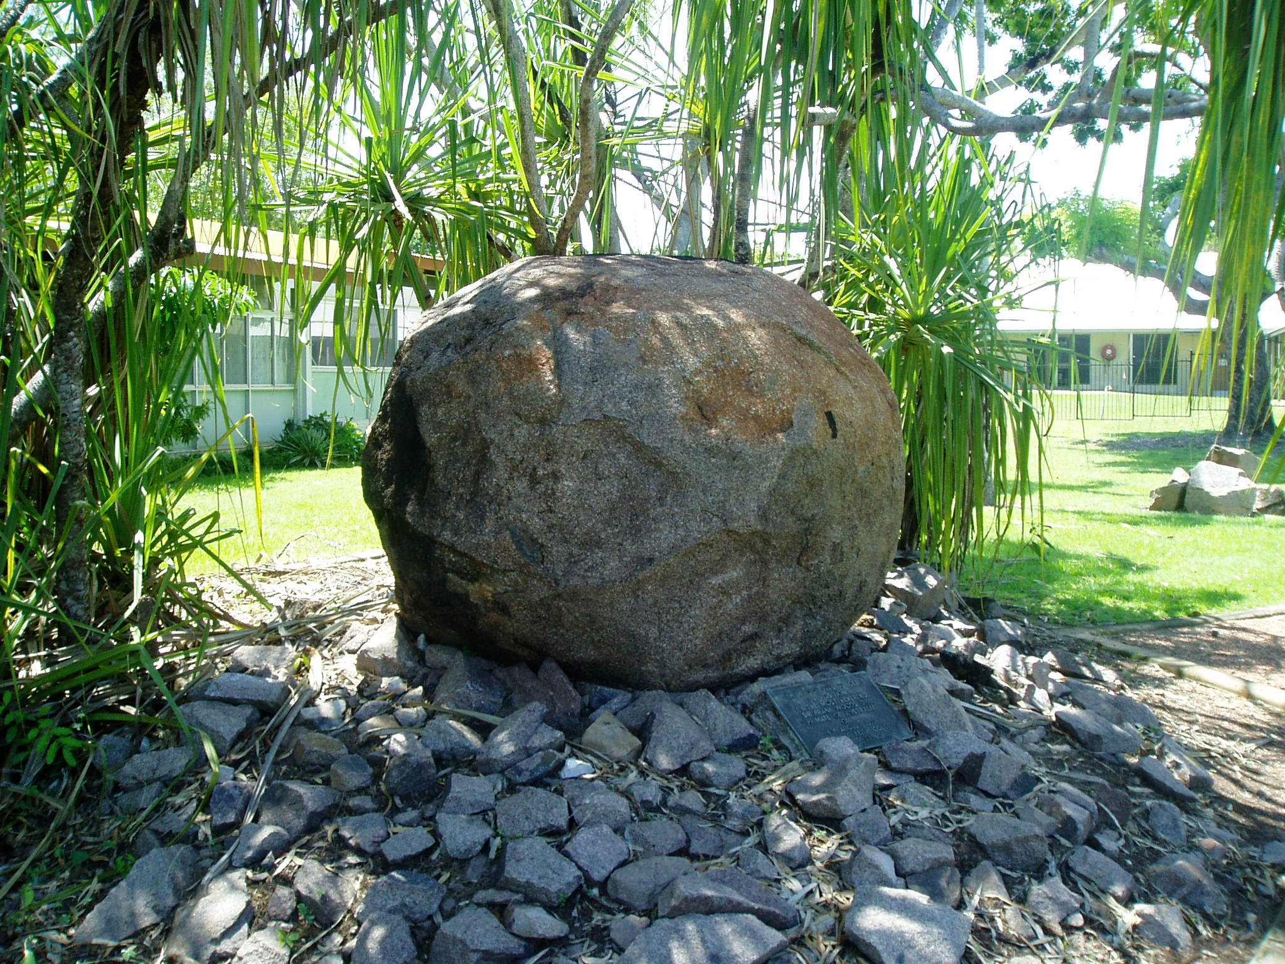
The rock at Nungalinya College
Aboriginal Land Commissioner Judge Mansfield 2006
Para 379: Bill Risk, Kenny Reid, Pauline Baban, Helen Secretary, Maureen Ogden, Joe Raymond and Tibby Quall gave evidence at the hearing in relation to ‘frog dreaming’. Susan Roman gave evidence on this topic at the Kenbi Claim in 1995. Out of these eight witnesses, six knew the location of the frog dreaming, near the Dripstone caves at Casuarina beach. There were varying descriptions of the significance of the site, with Pauline Baban and Helen Secretary warning against drinking the water or playing in the area. Helen said that the frog dreaming ‘watches over where Old Man Rock is’. None of the other witnesses raised either of these points. Similarly, Tibby Quall, Maureen Ogden and Pauline Baban were the only witnesses to give evidence of a ‘frog song’. No witness gave evidence as to water that drips all the time at the site.
Land Claim over Dariba Nunggalinya
Para 421: The Larrakia people lodged a land claim over Dariba Nungalinya, known as ‘Old Man Rock’ around the same time as the Kulaluk and Gundal land claims were lodged. Previously, in 1931 the Northern Territory Times had reported on an earth tremor in Darwin, recording that a ‘Larrakeeyah native’ insisted that the tremor occurred
‘because a certain King God turned over in his sleep. According to this informant there is a large stone or rock situated close to Casuarina Beach (is it Old Man Rock?) and reached by the tides at certain times. This rock is or was the First Aboriginal and the maker or beginner of the aboriginals of Australia.

This king god sleeps near Casuarina Beach and occasionally when disturbed turns over in his sleep causing the whole earth to shake with his movements.’

Para 422: The Adelaide Advertiser had published a similar article in 1931 referring to ‘a large stone close to the sea’ at Casuarina, believed to be ‘the King God, the first aborigine and creator of all others’.
Para 423: Dr Wells agreed with Mr Hughston in cross-examination that only one Larrakia person is referred to in the article in the Northern Territory Times as a source. Mr Hughston also suggested that the description of the ‘large stone or rock situated close to Casuarina Beach … and reached by the tides at certain times’ does not accord with the current location of Old Man Rock, which sits ‘several hundred yards out to sea’. Dr Wells agreed that an inconsistency existed, which she sought to explain on the basis of a ‘cross-cultural misunderstanding’, saying ‘I think it’s [the article] referring to the top of the rock, which Larrakia people … believe … is the head of the old man.’
Para 424: In 1975 Bobby Secretary made a submission to Interim Commissioner Ward which stated ‘Dariba Noongalinya, he is the dreaming place long long time ago may be a thousand years. Travelling around the country, came to here and turned to rock. If the white man put something there, something bad happen to this place Darwin … We want this place, nobody can touch it. … It is our job to look after it … Daribah Noongalinya belongs to Larrakia.’ Nipper Rankin, who also made a submission, said that ‘It is a very important place for Larrakia. Better you ask Tommy Lyons, Imabul, he’s the leader for business now’. In 1982 the Aboriginal Sacred Sites Protection Authority approved the registration of Old Man Rock as a ‘sacred site’, restricting access without the permission of the Aboriginal Areas Protection Authority.
Para 425: In 1994, Topsy Secretary spoke to the Northern Territory News and said that Dariba Nungalinya would cause danger if disturbed: ‘Dariba Nungalinya is a real sacred site. It’s not a joke. People might think it’s superstitious but it’s not, it’s real.’ It was also reported that Topsy Secretary had said that Dariba Nungalinya was responsible for Cyclone Tracy in 1974.
Para 426: Dr Wells said that she could not recall any references in the historical record to Old Man Rock between 1931, when the articles in the Northern Territory Times and the Adelaide Advertiser were published, and the 1970’s.
Para: 638: The Territory also pointed to a [NT News] newspaper article from 30 April 1994 headed ‘Revenge of Old Man Rock’, which quoted Topsy Secretary as saying that ‘native people used to talk to the Old Man in the Larrakia language when they went past’ [emphasis added].

Para 760: Dariba Nunggalinya (Old Man Rock) has already been referred to at some length. It is clearly an important Larrakia site, if not the most important Larrakia site. A number of witnesses gave evidence that it is a place where people are not allowed to go. Bill Risk said ‘humbugging around Old Man Rock can cause tidal waves or abnormal tides’. Mr Quall described his Uncle Victor Williams as the real custodian for Dariba Nunggalinya. The evidence also suggests that it is part of the Kenbi dreaming track from Belyuen to particular areas around the Darwin Peninsula. Not all witnesses had heard of that aspect of the story. Morris Fejo described the story at some length, and said that there are dances and ceremonies that are done for Old Man Rock, but he does not know what they are called and does not know them. There is also no other evidence to describe those dances or ceremonies.

